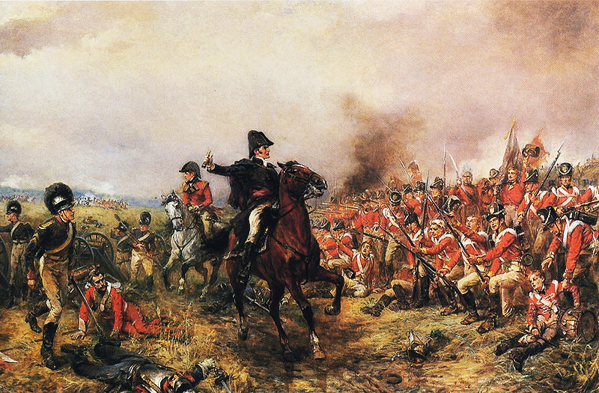

Who is Napoleon Bonaparte: Hero or Tyrant

Napoleon has attracted much attention from historians and has become a hero to many over the years since he lived and ruled in France. To them he carried on the beneficial aspects of the French Revolution of 1789. Others see him as just another tyrant who betrayed the ideals of the revolution, suppressing elections and bringing back the monarchy and aristocracy. But everyone agrees that he was an extraordinary man who left a lasting imprint on the world in which he lived.
Napoleon's own statements were contradictory. He called himself a "son of the revolution" and the champion of its principles: liberty, equality and fraternity. But according to the Marquis de la Cases' Journals of the Private Life and Conversations of the Emperor Napoleon, toward the end of his life he said that "revolution is one of the greatest evils by which mankind can be visited."
The government in the last phase of the French Revolution was known as The Directory. In 1799, 10 years after the beginning of the revolution, it ended. Because many prominent men, particularly Abbe Sieyes, felt that the Directory was failing, they invited the successful young General Napoleon to take power. He became part of a triumvirate, three consuls. The consulate had full power, and elections were ended. Napoleon assumed the position of First Consul and obtained near dictatorial powers.
The Consulate made government in France more efficient and abolished most of the remnants of class and privilege. He created a meritocracy, advancing men in public service according to their ability, not on their birth. The feudal system was dead.
Those who supported him and cooperated with him were rewarded. Those who he believed were a threat were ruthlessly eliminated.
Napoleon achieved reconciliation with the Catholic Church. France had been divided since 1789, when the National Assembly put the church under state control. The Pope had lost the right to appoint priests and bishops in France. Church lands had been confiscated. Who was now the rightful owner? The Church in Rome claimed to be. This caused great instability and Napoleon was determined to end the discord.
In 1801 he signed an agreement with Pope Pius VII reestablishing the Church in France.. It was The Concordat of 1801. But it was under Napoleon's terms. The Church agreed to give up their claim to the lost lands. The principle of religious freedom which the revolution had guaranteed remained in effect. The government would continue to select the bishops, but would submit them to the Pope for his approval. Bishops would appoint only priests acceptable to the government. In return Napoleon graciously recognized the Catholic Church as the religion of the great majority of Frenchmen. The Church had lost much, but the dispute was over.
Between 1798 and 1802 Austria, Russia, and Britain were joined in the Second Coalition against France. Napoleon continued to successfully lead the French armies and brought peace to France in 1802, ending the Second Coalition.
He tried to create peace within France by providing an amnesty to all political refugees, and filling his government offices with people of diverse political beliefs.
Because he had brought peace to the land, both domestically and in foreign affairs, Frenchmen rewarded Napoleon with the office of Consul For Life in 1802.
By 1804 Napoleon had dictatorial power and was a monarch in all but name. He announced that he would be crowned emperor, and the people overwhelmingly voted in a plebiscite to support him. His power would now pass to his eldest son; he was Napoleon I.

Reforms in Law:
In 1804, Napoleon took on the legal system of France. The system of laws was in a state of chaos. Laws were not codified and were based on Roman law, ancient custom or monarchial paternalism. During the revolution, many laws were changed. It was difficult to determine what law applied in any given situation, and laws were not equally applied to everyone.
The mishmash of laws were codified and written clearly so that the people could determine what law applied. It incorporated much of the Roman law. For the first time in history, the law was based on reason and founded on the notion that all men were equal before the law. It guaranteed individual rights (except for women and blacks) and the security of property. In short it codified many of the ideals of the revolution. The Napoleonic Code became profoundly influential to other European countries in the 19th century.
Reforms in Government:
Napoleon centralized the government, putting control firmly in the hands of the national government. It became more efficient. Advancement in the civil service and the military was based on merit rather than rank. The tax system was applied equally to all.
Reforms in Education:
Napoleon built many new lycees, schools for boys age 10 to 16. He recognized the importance of education in producing citizens capable of filling positions in his bureaucracy and military. Although he did not create a system of mass education, education was more available to the middle class than it ever had been before. At a meeting in 1807 he declared:
“Of all our institutions public education is the most important. Everything depends on it, the present and the future. It is essential that the morals and political ideas of the generation which is now growing up should no longer be dependent upon the news of the day or the circumstances of the moment. Above all we must secure unity: we must be able to cast a whole generation in the same mould.”
He saw education as a way of indoctrinating "right-thinking" citizens from an early age. He didn't see the need to educate girls, since they could learn everything they needed from their mothers. They were not to be active citizens.
In 1803, France was once again at war with Great Britain, and by 1805, Great Britain, Austria, Russia and Prussia had united to form the Third Coalition. Within two years Napoleon crushed the other European powers. With the defeat of the Third Coalition and the conclusion of the Treaty of Tilsit with Alexander I of Russia, Napoleon controlled most of Western and even Central Europe (from Spain to the Grand Duchy of Warsaw, with the exception of the Habsburg lands).
After squashing the Habsburgs in the Austrian Wars of Liberation in 1809, he accepted Habsburg offers of reconciliation and married the Habsburg Archduchess Marie Luisa. Though never a love match, Marie Luisa bore Napoleon a son. The succession was secured and his claim on central Europe was stronger.
By 1812 Napoleon felt he must invade Russia. When Russia abandoned the continental system it was just a matter of time before war. Napoleon was determined to get there first and so led a huge army of 600,000 into Russia.
Instead of giving battle, the Russians retreated, destroying everything that could be of use to the French. Napoleon had always lived off the land in his campaigns in order to forestall a supply problem. Now it was impossible. When he reached Moscow in September he found it burning. There was nothing there which could feed and house his troops for the winter.so he was forced to turn back toward home just as winter was setting in. His Grand Army ran out of supplies and soldiers died of disease and the bitter cold of the Russian winter. They were clad only in summer uniforms. Russian troops continually attacked them as they trudged home. Only 40,000 survived the march.
At this point, the anti-Napoleonic forces gathered together. Over the course of 1813 and early 1814, Great Britain, Russia, Prussia and Russia, as well as a host of other small countries, drove Napoleon's forces back to France. This was the turning point.
Though the Great Powers offered Napoleon the opportunity to surrender and remain Emperor of France (the Frankfurt Proposals), Napoleon refused. The invasion of Russia had proved his undoing.
On March 31, 1814, Paris fell, and days later Napoleon abdicated. He was imprisoned on the island of Elba, but the island could not keep him. He landed in France on March 1, 1815, while at the Congress of Vienna; the powers of Europe were dividing up the continent. The people still loved him, and he was welcomed in Paris. He took control of the government and army and again went to war. But the odds were against him. The Quadruple Alliance of Austria, Russia, Prussia and Great Britain defeated Napoleon at Waterloo. Napoleon's One-Hundred Days convinced the Great Powers to force France to submit to a stricter peace treaty, and to agree that no Bonaparte should ever again rule France. They exiled Napoleon to the island of St. Helena, where he died in 1821, apparently poisoned.
Though the French Revolution was a failure in France, thanks to Napoleon its ideals spread throughout Europe. As his soldiers marched they carried with them ideas of equality. Later monarchs found the seeds of liberalism planted by the French were impossible to eradicate.
The French also awakened nationalism in 19th century Europe. They were a vivid example of what nationalism meant and they inspired nationalism in defeated nations as the hated conquerors and oppressors. Europe would never be the same.
He brought an end to the violence of the French Revolution while preserving many of its core ideals. He was extraordinarily popular with the French people, a figure larger than life who made the common man proud to be French. However, during his reign as Emperor, individual rights were suspended. There was little freedom in France. He became the model of the autocratic, popular leader who takes absolute power with the will of the people. Hitler, Mussolini, Franco, Pinochet and others consciously followed his path.
Tyrant or Hero? Perhaps a bit of both.

