Psychological Melodies
Mr. Cass
2015
Psychology
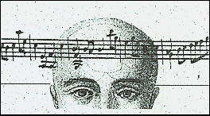

Objective: To gain a unique understanding of psychological and developmental theories studied in unit two (3.2, 3.3, and 4.2), and realize that psychology lurks everywhere – even within the poetry of music.

Task 1:
- Students will identify and describe a psychological or personal developmental theory from the bullets below.
  - Psychosexual, Psychosocial, Moral, or Cognitive
  - Adolescent developmental theory
  - Theory of Identity Crisis
  - Social Learning Theory
- Students will identify the person most associated with the theory (designer).
- Students should be able to identify the various stages of the theory.

Task 2:
- Using the chosen theory, retreat into your subconscious and think of a song that describes, in a sense, the theory – or – a particular stage(s) of the theory.
  - Before deciding on a song, review the lyrics to ensure the accuracy and relevance of the song’s lyrics to the theory.
- Prepare a brief (1-3 minutes) oral presentation that explains your reasoning and decision to choose the song.
  - In brief, explain:
- Why does the song describe your chosen theory – or – particular stage of the theory?
- Rewrite the title of the song so it is suitable for the chosen theory. (For example, Another Brick in the Wall, by Pink Floyd could possibly be retitled: Conformity)
- Finally, share the lyrics and song with the class.

Assessment: See: Psychology Presentation Rubric for Providing Feedback

