Industrial Revolution
Two- Sided One-Pager
Due Date: Tuesday, April 21, 2020
https://kopywritingkourse.com/one-pager-examples/

Objective: As a way to review and gain a better understanding of the Industrial Revolution and accompanying, Hip Hughes Video Lecture, each student will create a TWO-SIDED informational poster called a “One-Pager” that includes all information within the numbered tasks listed below. The TWO-SIDED one-pager allows for a single (TWO-SIDED) - page response to a reading or concept in which students can react creatively and imaginatively to a topic in a concise, compressed, yet detailed assignment.
NOTE 1: This assignment will serve as your Chapter 25 test and is worth 60 points
TIMING IS EVERYTHING: Your will have an entire week to complete your pager. Therefore, organization of applicable information, brainstorming designs or templates for pager as well as artistic elements must begin immediately.
NOTE 2: This assignment is posted on my website.
NOTE 3: If there are any issues with obtaining art supplies to complete this by hand, the digital option is required.
One-Pager Style:
- Pager Style Options:
  - Digital image (TWO SLIDES) of pager sent via email in a PowerPoint slide or SHARED Google Slide that Mr. Cass can download and view.
- The digital option may ONLY HAVE TWO SLIDES
- The digital option will require a balanced layout using a template you can find on the link above with all required information organized artfully on one page.
- Colorful hand drawn or digital illustrations
- See image below of digital one-pager as well as this link for examples:
- https://eur05.safelinks.protection.outlook.com/?url=https%3A%2F%2Fwww.google.com%2Fsearch%3Fsxsrf%3DALeKk03V6_kE5w7_S8vwCExjwXl-XMbVXw%253A1586432959591%26ei%3DvwuPXojUI8-v_QaVua7oAw%26q%3Deasily%2Binfographic%2Bhistory%2Bimages%26oq%3Deasily%2Binfographic%2Bhistory%2Bimages%26gs_lcp%3DChNtb2JpbGUtZ3dzLXdpei1zZXJwEAM6BAgAEEc6BAgjECc6BQghEKsCOgQIHhAKOgQIIRAKUIOUAVjdpwFg-rMBaABwAXgAgAF_iAGjB5IBAzAuOJgBAKABAQ%26sclient%3Dmobile-gws-wiz-serp%23imgrc%3DJBTCO5q9NFdJxM&data=02%7C01%7C%7C4ccb5277586f49b0e50008d7dc7c57a0%7C84df9e7fe9f640afb435aaaaaaaaaaaa%7C1%7C0%7C637220298903063256&sdata=KhC1OZf45m8MDj3%2BcvIWYjPAyZw4V53h8rmCqFa5nyc%3D&reserved=0

  - TWO-SIDED Poster – 11x14 unlined paper
- The poster option will require all elements to be handwritten (nothing typed and pasted) and hand drawn (nothing printed and pasted)
- Use of colored pens, pencils, crayons, and markers are required. Why? The more visual appealing your pager is, the more someone is willing to view it and learn from your topic.
- See images below of hand-drawn one-pagers

Content:
- Visible unique title (centered on pager)
- Illustrations that depict the specific details within your pager’s information
- Important information from ALL 4 sections. For example: 25.1 – Origin of Revolution, 4 Causes (Why England?), ALL effects (CAUSES AND EFFECTS – SEE HIP HUGHES VIDEO LECTURE), 25.2 – Industrial life, etc.
  - NOTE: Simply follow the themes and headings of each section as a guide
- A minimum of 2 inventors AND their inventions
- A minimum of 2 social reformers AND their beliefs
- A minimum of 4 applicable vocabulary AND their definitions from anywhere in the chapter
- A minimum of TWO quotes from major role players in the Industrial Revolution
  - Each quote must contain quotation marks and attribution (Who said it?)
- Neatness and creativity are SIGNIFICANT elements of a One-Pager (see rubric).
- How can anyone read and learn from something that is not legible, detailed, and well-ordered?
- How can anyone be inspired by something that is not visually appealing?

Submitting: Submit your TWO-SIDED One-pager by taking a picture of both sides and emailing me or emailing me your PowerPoint or SHARED Google slides.
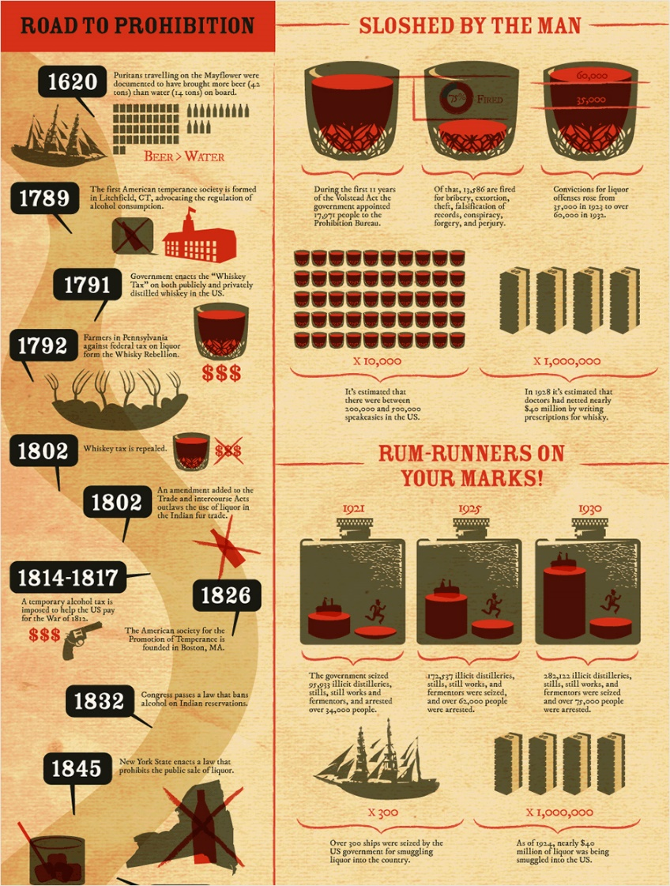
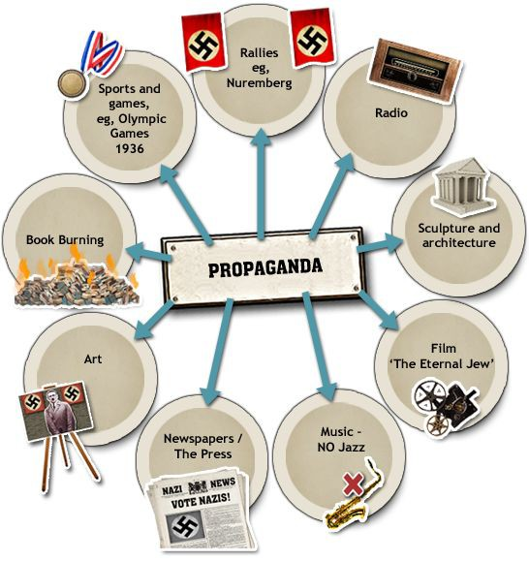
Assessment: See One-Pager rubric posted beneath this assignment.
