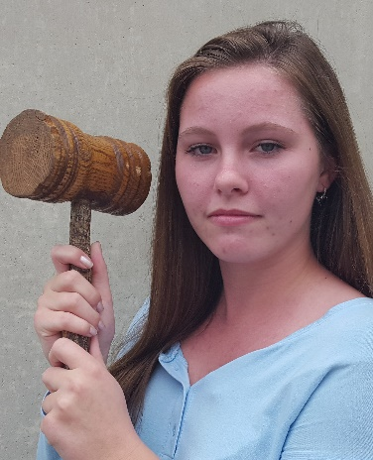
Judgement Day
By Erynn Phillips

Erynn Phillips was born in Long Island, New York and moved to Port Charlotte, Florida when she was three. She then moved to Punta Gorda, Florida in the middle of fifth grade and sometimes travels north to visit her family. Throughout her life she viewed the injustice throughout the world and wanted to make a difference. Ever since she was young, she had a strong distaste for unfair situations. She aspires to become a judge to stop prejudices and educate others on the importance of following the laws correctly in order to have a stable society. She also hopes to encourage others to evaluate situations from multiple perspectives and think for themselves.

. . .
B

reaking news always got my attention. The most interesting, and at the same time baffling, stories were the ones about criminals. I was extremely curious to see the pure ignorance of people thinking that they could get away with their attempted crime. It also startled me to see how many people deviated from the laws of our country. It was not the opposition to social norms that startled me, but the rejection of the actual rules that keep society functioning. The news largely impacted my way of thinking because I would only pay attention to the facts reported and draw my own conclusion without prejudice. The most upsetting thing to me, however, was when I would hear about someone who was arrested due to bias. Injustice occurs when people misinterpret what the law states, or, when someone does not know their rights as a citizen. This, in my opinion, is the worst kind of injustice and one that I hope to stop someday. I aspire to be a judge that is always fair and understands the law so that I can help others to understand it, too. This is where the conflict theory, or, the theory that states deviant behavior is decided by those in power to stay in power (Shepard and Greene, 116), comes into play. I want to be in “power” as a judge, but, use my influence and authority to positively impact society and make sure people are treated equally. Those who use their control for personal gain are exactly who I wish to expose and stop. In her article, Media Influence on Courts: Evidence from Civil Case Adjudication, Claire S. H. Lim supports this line of thinking by writing about the corruption in the courts, “The civil justice system in the U.S. has long been criticized for frivolous lawsuits, pro-plaintiff bias, and excessive punishment of corporate defendants, which may easily undermine the efficiency of the economy” (Lim, 2). This, among other things, is why I want to be a judge and change how things work. In my experience, too many people let their personal opinions get in the way of what is fair under the law. For instance, many people did not want gay marriage to be legal because they personally felt uncomfortable with it because of religion, prejudice, or personal experience. Emotions have nothing to do with the legality of it, and because so many people put their values ahead of logic, it was debated for quite a long time. Conformity is partly to blame for this because people forced their feelings onto others and pressured them into thinking the same way. By looking back about sixty years we can see a prime example of this. Segregation was an awful experience for those being discriminated against. Restricting someone solely on the basis of their skin color is morally wrong but people continued to do it during this time period. This shows that complying to the majority can sometimes have a negative effect on society.
When growing up, many people are largely influenced by pop culture. This is an instance in which conformity is not a positive influence on young people. Youth are very impressionable, so, when they have a whole community of people encouraging them to adhere to certain standards, they will. Normally, I wouldn’t mind this because people should be free to do what they please, however, these standards can lead to harmful actions. Sex, drugs, drinking, and partying are glorified by pop culture; and, this causes emotionally and cognitively undeveloped teenagers to believe that it is okay to participate in these activities because the “cool” artists participate in these activities. In reality, this leads them to believe they are mature enough to handle certain situations that they are not mentally or physically ready to handle. Throughout my life I experienced this glorification of inappropriate behavior and it made me very frustrated. For example, in school boys disrupted class and other kids were encouraged by their classmates; and, girls would make a scene or start drama just for attention and popularity. I didn’t understand that it was normal, and common, for people to be easily influenced by this behavior. This relates back to my dislike of the influence upon personal perspectives in the rulings of the court. In David Papke’s essay The Impact of Popular Culture on American Perceptions of the Courts, he states that the way pop culture perceives the court system influences how young jurors make their decisions. It didn’t make sense to me, but now that I have taken Sociology, I understand that humans are often manipulated to conform. The control theory, which states that conformity to social norms depends on how strong the link the individual has to their community, explains why I have never liked the influence pop culture has on people. My bonds to popular culture are feeble because I normally strayed away from the majority. I tried, and continue to keep an open-mind when it comes to equity so it aggravated me when others did not.
My aggravation sprung from my longing to make the world better. That may sound unusual, but to put it simply, I am frustrated with rebellious actions that clash with social decency, and the law, because I care about the general good of the people. I seek the truth in order to bring justice to those treated unlawfully and encourage others to stray from negative influences by embracing their individuality. With my inclination toward logic and reason, I strive to improve society as best I can and guide others to happier lives.

Works Cited
Lim, Claire S. M. “Media Influence on Courts: Evidence from Civil Case Adjudication.”
American Law and economic Review 17 (2015) : 87-126. Web. 10 May 2016.
Papke, David. “The Impact of Popular Culture on American Perceptions of the Courts.”
Marquette Law Scholarly Commons 82 (2007) : 1225-1234. Web. 9 May 2016.
Shepard, M. Jon and Robert W. Greene. Sociology and You. Columbus: Glencoe McGraw-Hill,
2003. Print.

